KKS2 -

Functionality
The system compares the control costs with the target costs and assigns the variances to variance categories. The variances are assigned to variance categories in the following sequence:
- Input price variance
- Resource-usage variance
- Input quantity variance
- Remaining input variance
- Mixed-price variance
- Output price variance
- Lot size variance
- Remaining variance

Variance = 0 if only partial Goods Receipts has been performed.
Variance = amount if only complete Goods Receipts has been performed.

Scenario
You want to calculated Variance either when Order is completed or at month end. Variance must be calculated when order is completed. In this case Variance = amount. Variance must also be calculated at month end even though order is not completed. In this case Variance = 0 (all left over amount is considered as WIP in this case).

Requirements
WIP has been calculated at the previous step.

Menu Path | Accounting → Controlling → Product Cost Controlling → Cost Object Controlling → Product Cost by Order → Period-End Closing -> Single Functions → Variances → KKS2 - Individual Processing
Transaction Code | KKS2

1. Double click on KKS2 - Individual Processing.

Variance Calculation: Initial Screen

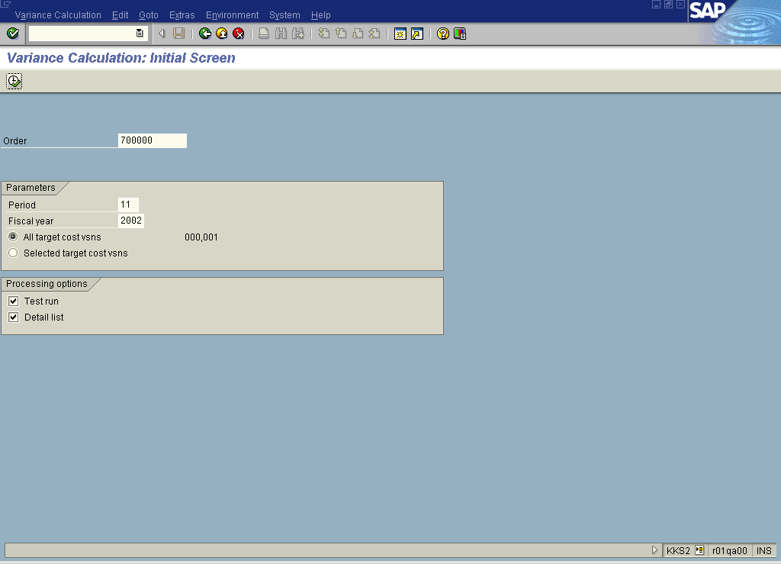

2. Update the following fields:

Field Name | Field Description | Values
Order | Number identifying the order | Example: 700000
Period | Number identifying a fiscal month. | Example: 11
Fiscal year | Fiscal year for which you calculate variance. | Example: 2002

3. Click the Execute button.

Variance Calculation: List

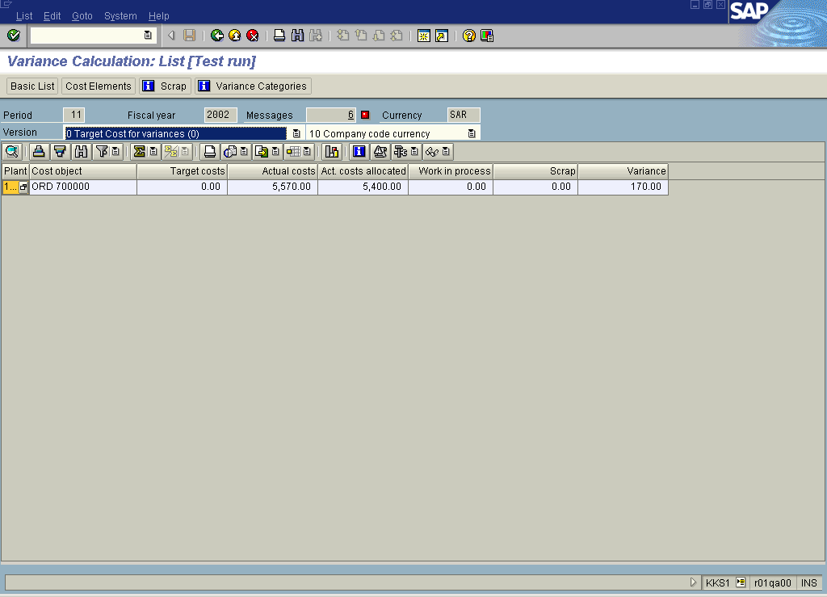

4. Double click on the Variance 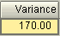 field in an ORD 700000 line.

Variance Calculation: List

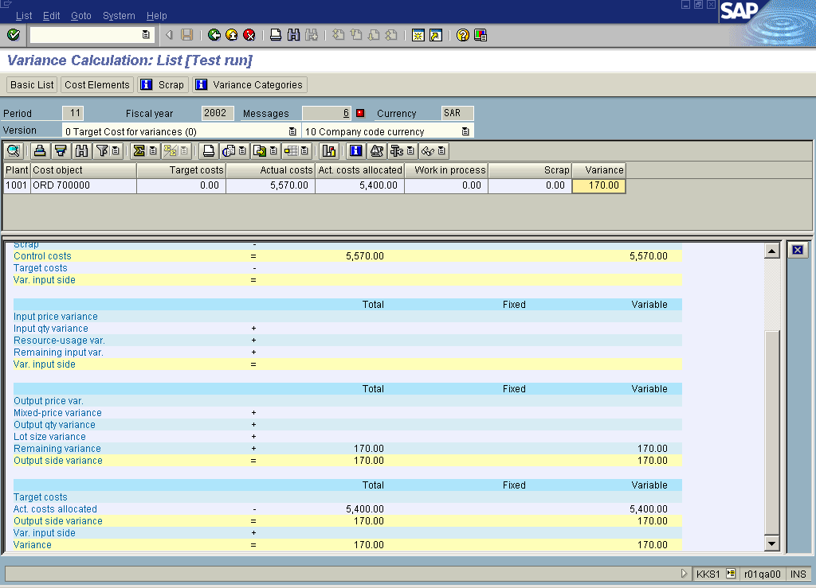

5. Click the Cost Elements button.

Variance Calculation: List

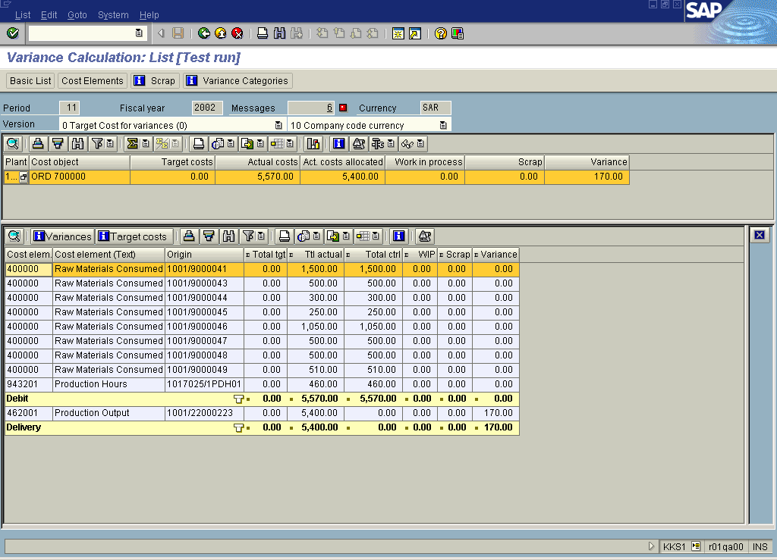

6. Click the Basic List button.

Variance Calculation: Basic List

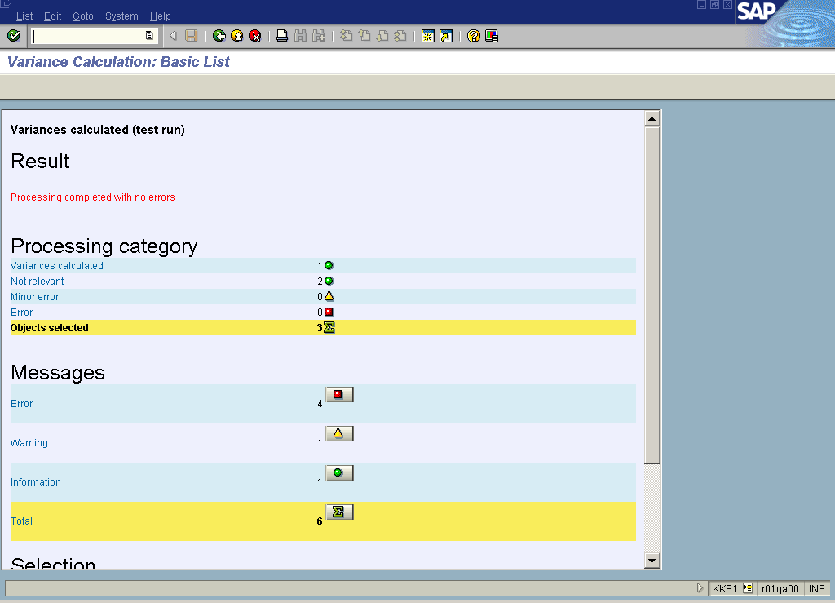

Note: You can click the massages icons to check details.

7. Click the Back button.

Variance Calculation: List

8. Click the Back button.

Variance Calculation: Initial Screen

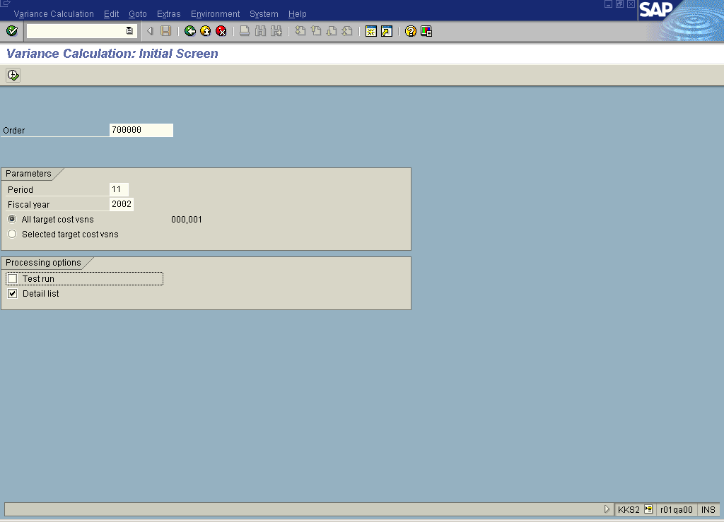

9. If you are satisfied with the results, repeat the same process in Production mode by deselecting the Test run checkbox.

10. Click the Back button to go back to SAP Easy Access screen.

